Parts where we can add depenedencies

-> Pom.xml

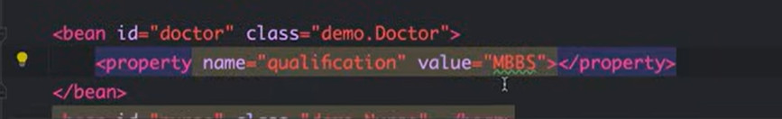

How to add values you to the paramters of doctor, when creating if you don’t want to get null,

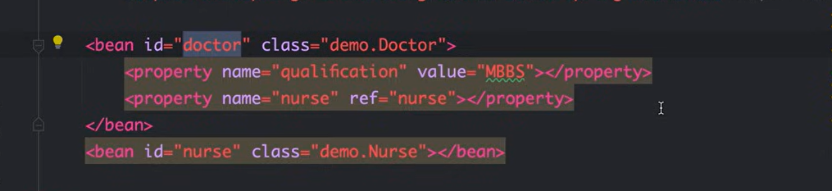

If you want to inject nurse into doctor, we can do this, by getteres and setters by having a paramter int the class of doctor.
Annotations start

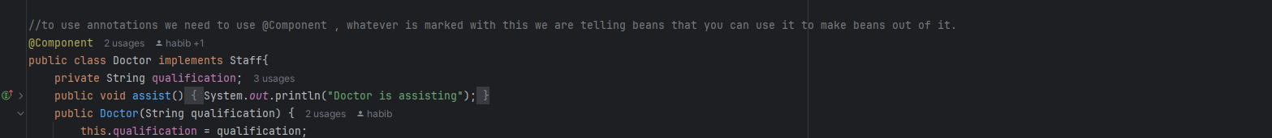

We add this line

In xml to show spring where to find our componenets
.

-> There are many annotations where we have to learn here they are moving to java config.

Checking for doc change

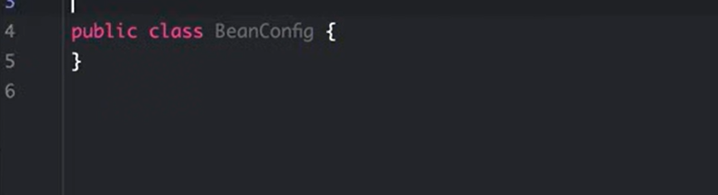

Different Scopes available in Spring Bean

- By default Spring will create the object in a singleton scope, that means there is only one single object availabe in the entire application. There are 5 Scopes available listed below.
- 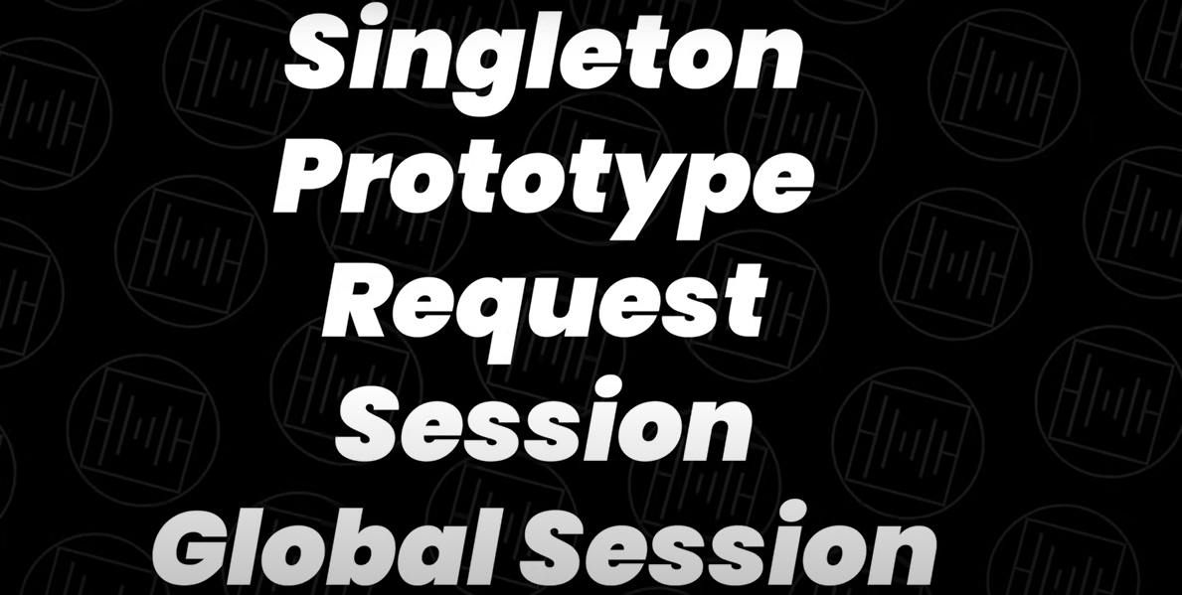
- Request, Session, and global Session are used manly when there is web context available, this we can see when we are dealing with Spring MVC. We can see the rest tho.
- Singleton -> Same object
Request-> Different Type,
Request is used when you need different type of object every time when you receive a request to the application.

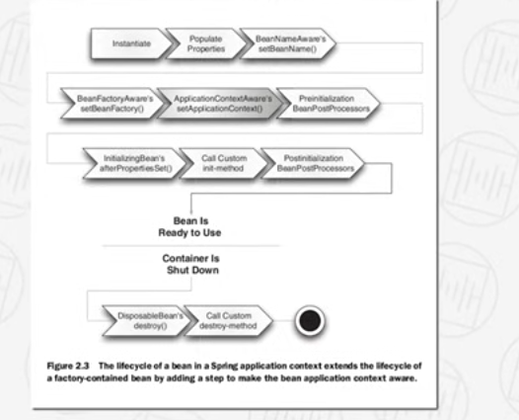

Bean Lifecycle
Ask about Aware Interfaces

AOP

Remove cross cutting concerns like authenticating (Boiler code) from business logic.

What is Spring Boot

Spring is a framework to create enterprise ready applications. Spring Boot is extension of Spring.

Spring Boot provides different starter templates with all the dependencies. It provides Auto Configuration.

Dependency Injection

Checking name

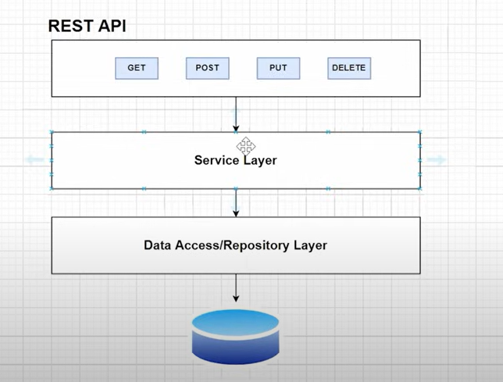

All the business logic that we ant to deal with the data which comes from the DB we do it in the service layer.
Data Access or Respiratory Layer is the layer which is responsibly for interacting with the DB.

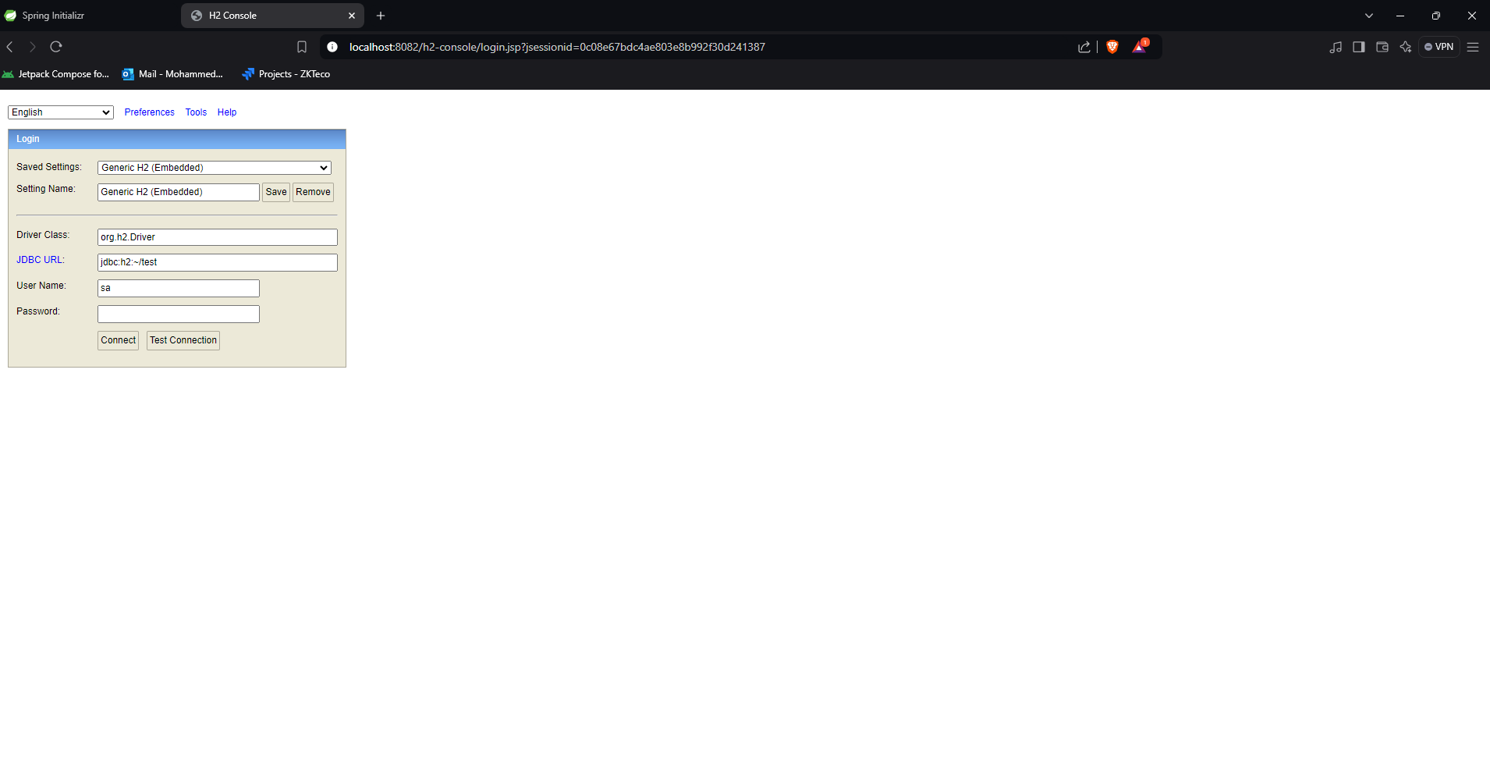

After configuration of h2 DB, adding things in the application file and then pom.xml file and then if you go to this URL you will get this.

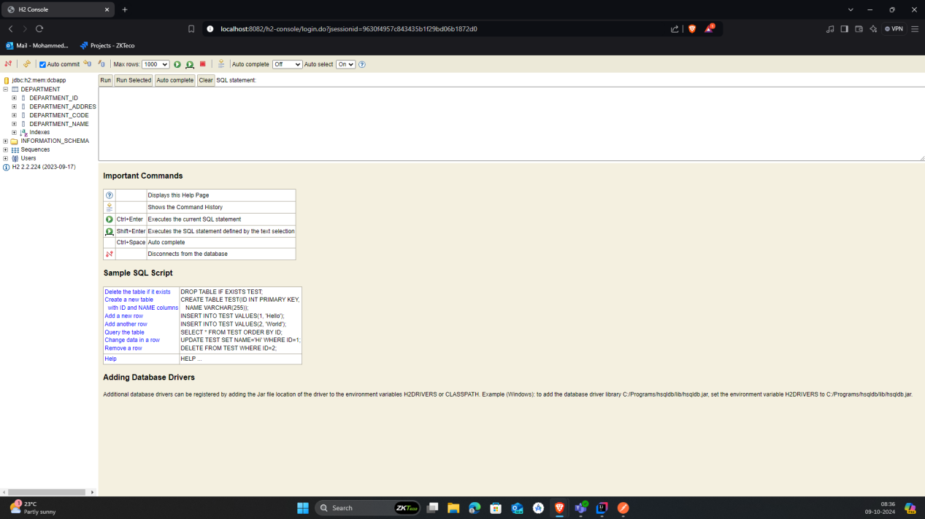

After adding all the entity and department code and all you see that the DB is already there when you login to h2 console.

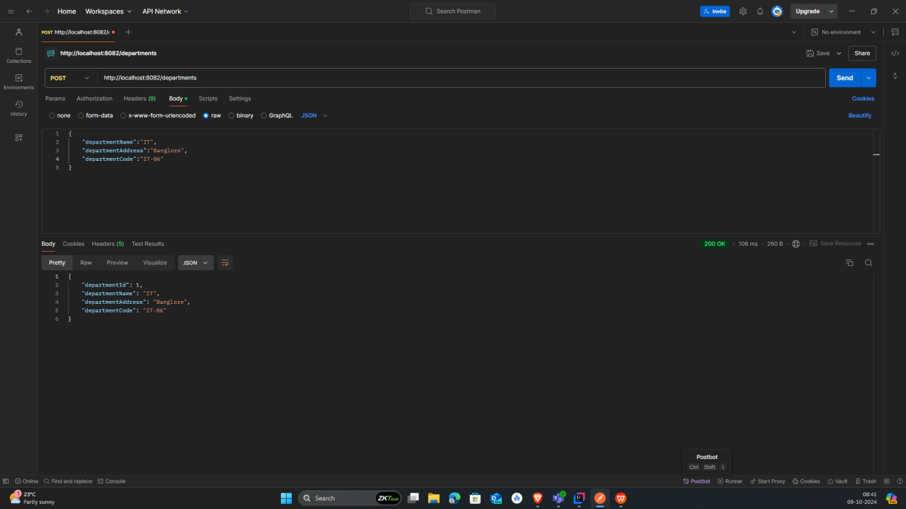

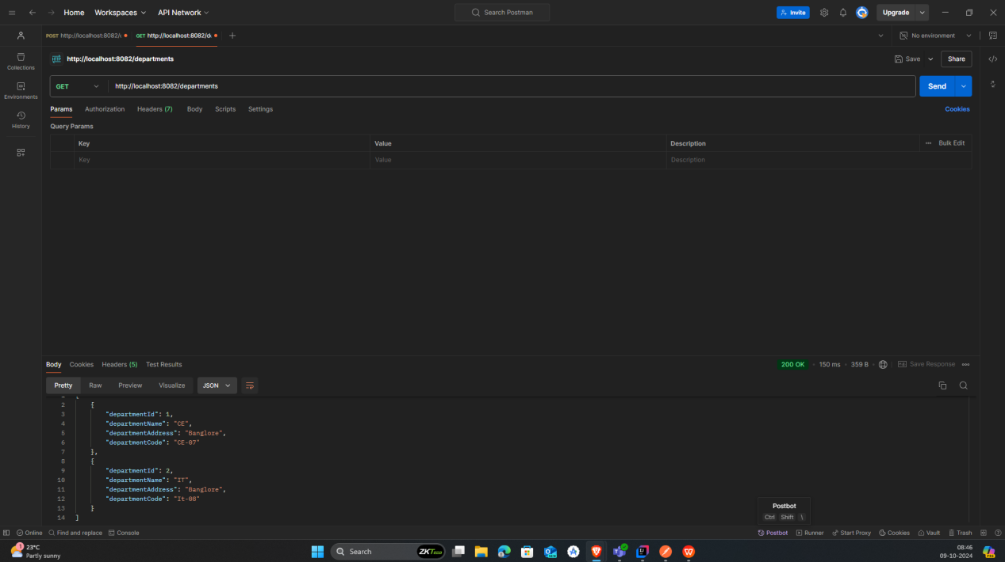

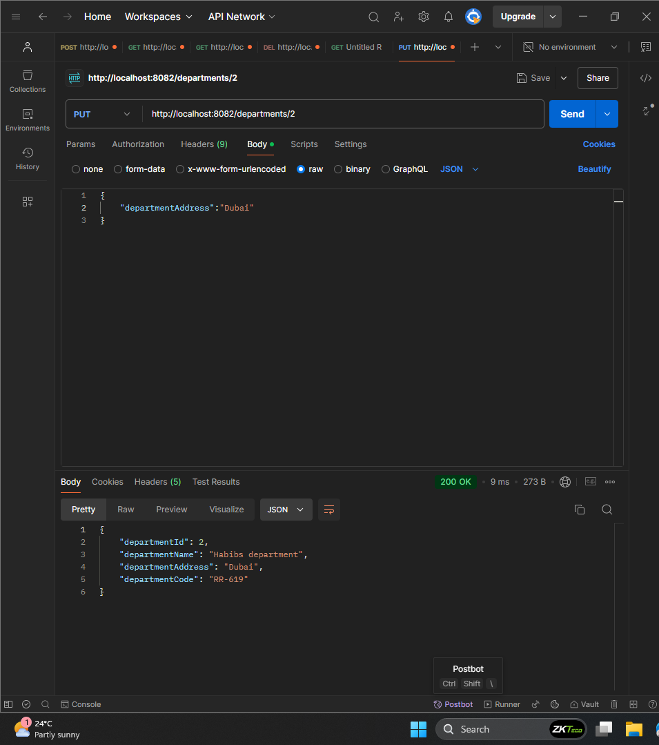

You can do this as well, where you only change the address and nothing else since we wrote code that only checks the things we sent and changes only those.

https://docs.spring.io/spring-data/jpa/reference/#jpa.query-methods

this is to retrieve information from the DB, just how what to write for queries

